1. Install VS Code
2. Install from nodejs.org
3. Go to “Edit the system variables” ---Environment Variables--- System Variables--- Path (Edit)--- New

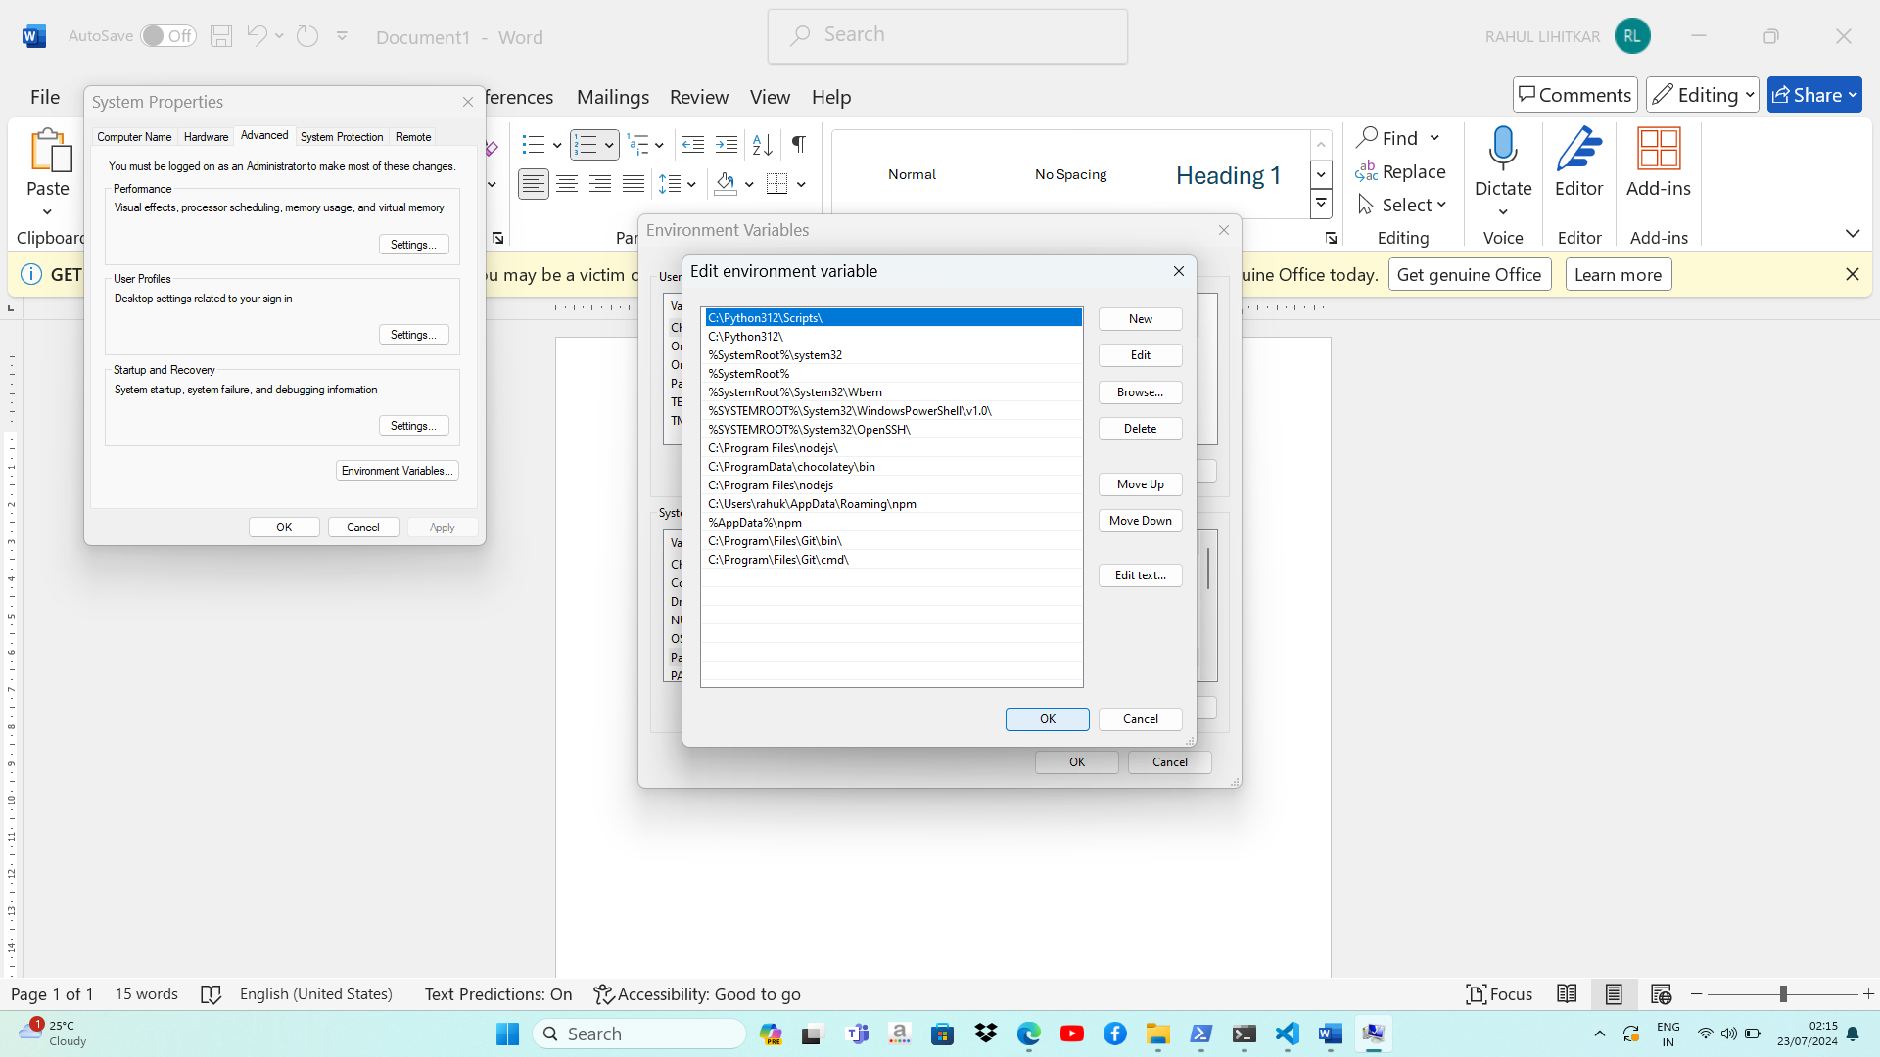

1. Create a folder --- here it is C:\ang project\ Task_Management_System
2. Open cmd from the above location
3. 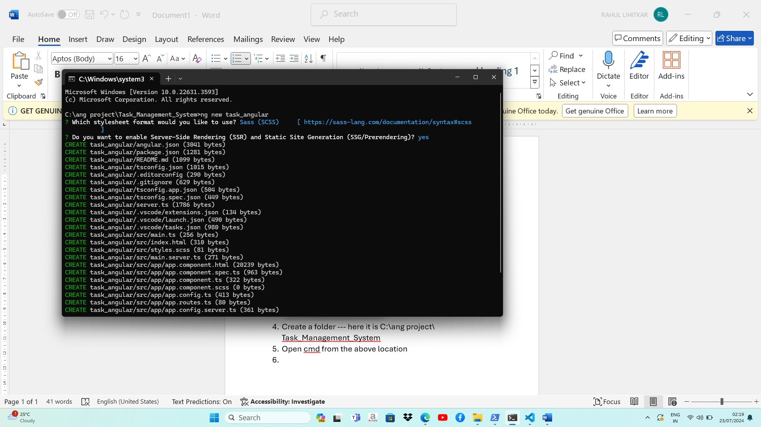
4. “ng new task_angular”
5. Open VS code from the “task_angular” location or just cd and reach to the location in VS code
6. 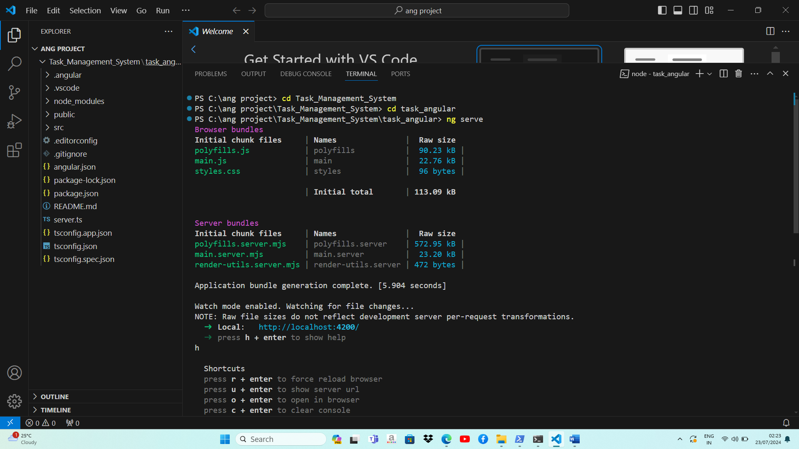
7. To run the project use “ng serve”
8. Install angular material using “ng add @angular/material” and proceed with yes to the next question
9. 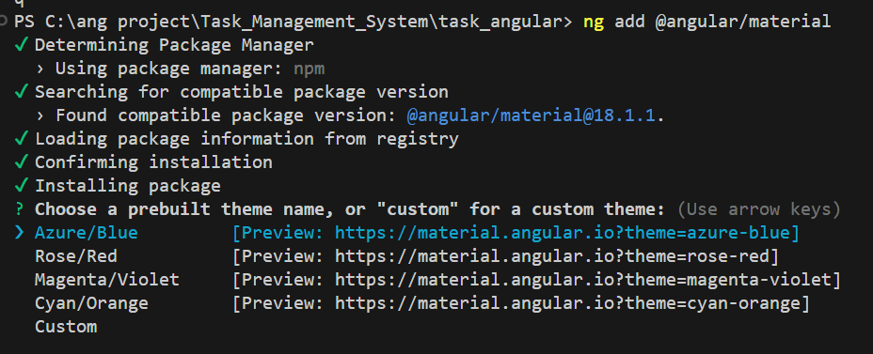
10. Go to the browser and search “spring initializer” [Spring Initializr](https://start.spring.io/;)
11. Project- Maven; Language- Java; Spring Boot- 3.3.2; Packaging- Jar; Java – 17
12. 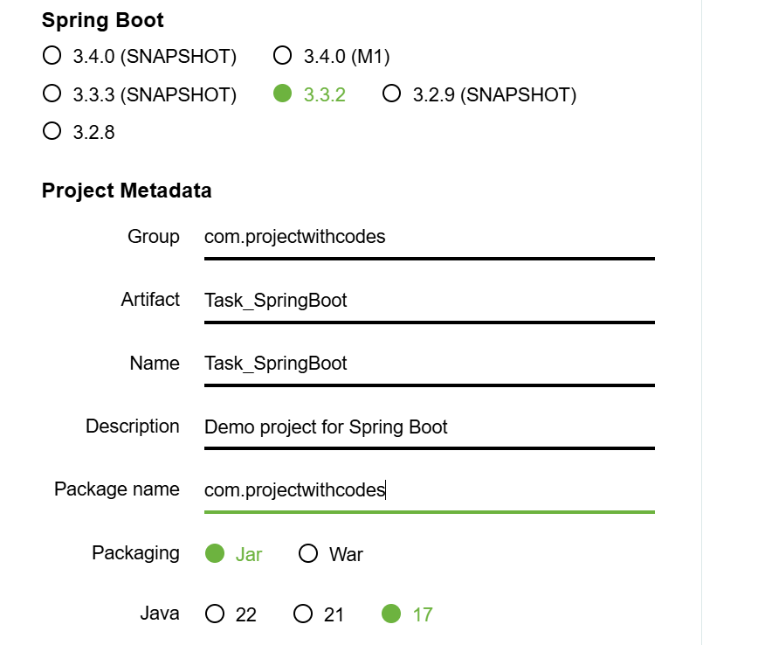
13. Add dependencies – 1. Spring Web 2. Lombok 3. MySQL Driver 4. Spring Data JPA
14. 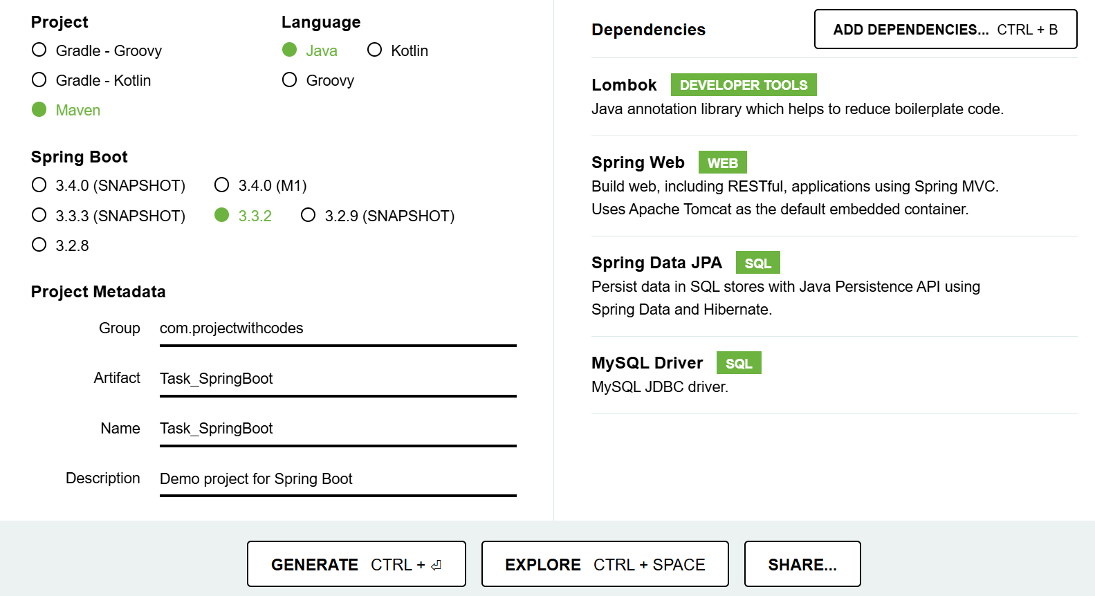
15. Click “Generate”

**Another Project**

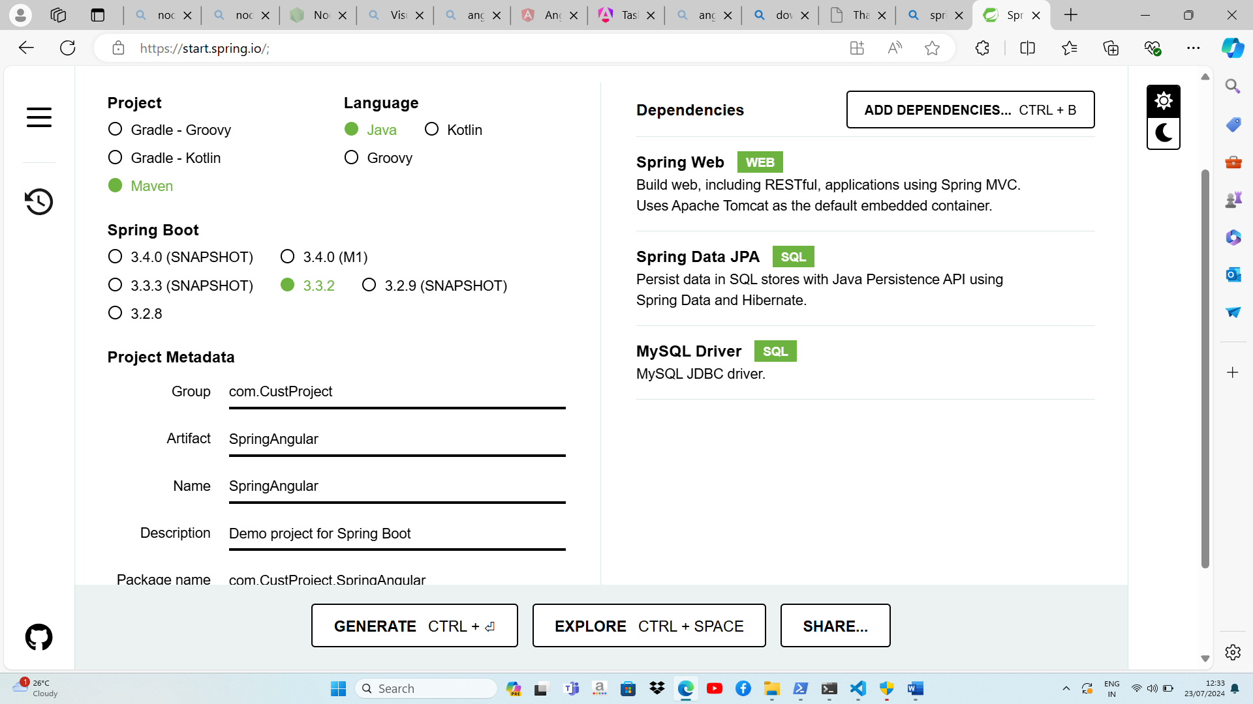

Packaging: Jar

Java: If possible, select 8 as 8 is a stable version

Generate

Install IntelliJ IDEA, scroll down on the JetBrains website and download the COMMUNITY EDITION .exe file for IntelliJ

Click next, check the uppermost 3 checkboxes and the necessary packages --- click next --- finish

Open project “SpringAngular” that you cut & pasted from downloads to your “Ang Project” folder

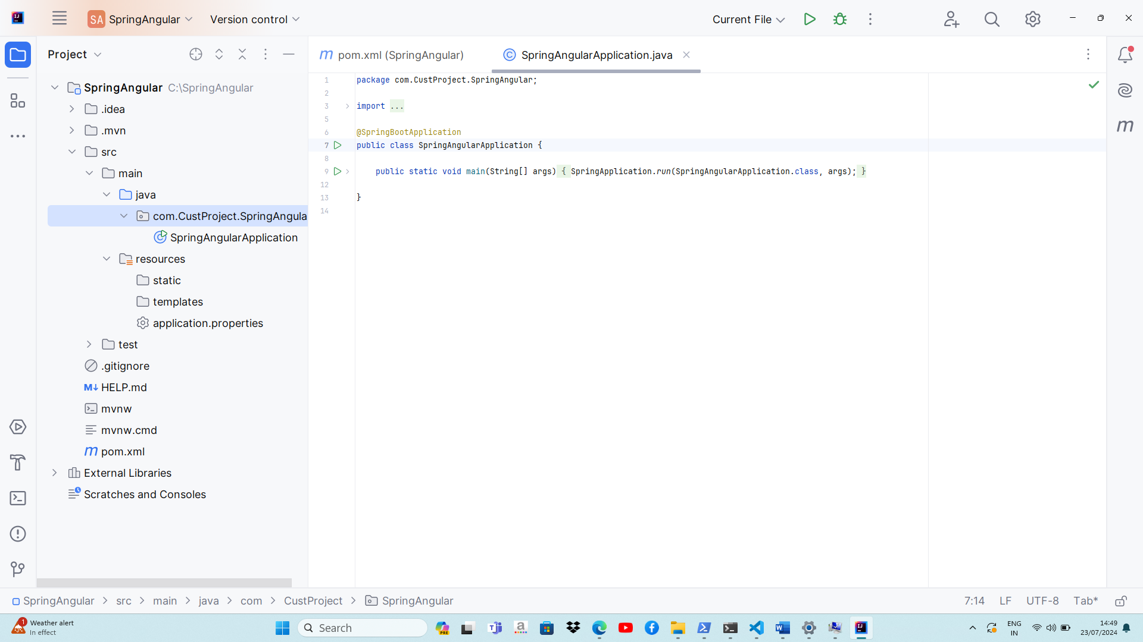

pom.xml contains all the dependencies

Main class of the project is in src folder --- java --- com.CustProject.SpringAngular --- SpringAngularApplication as shown in the above diagram.

Connection of ports is done in src --- resources --- application.properties

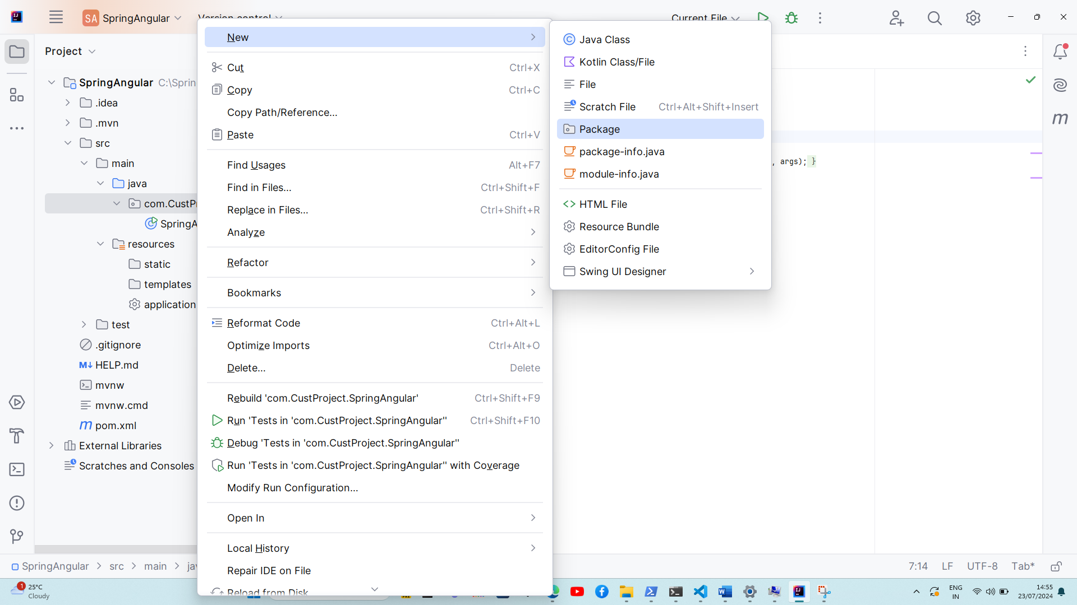

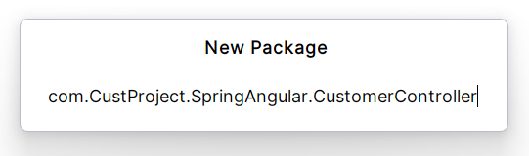

Right click on “com.CustProject.SpringAngular” --- new --- Package --- give a name to the package as shown above

Create all the packages one by one

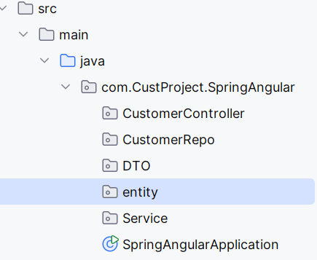

Creating a class:

Right click on **CustomerController package**--- new --- Java Class --- type CustomerController to create the class

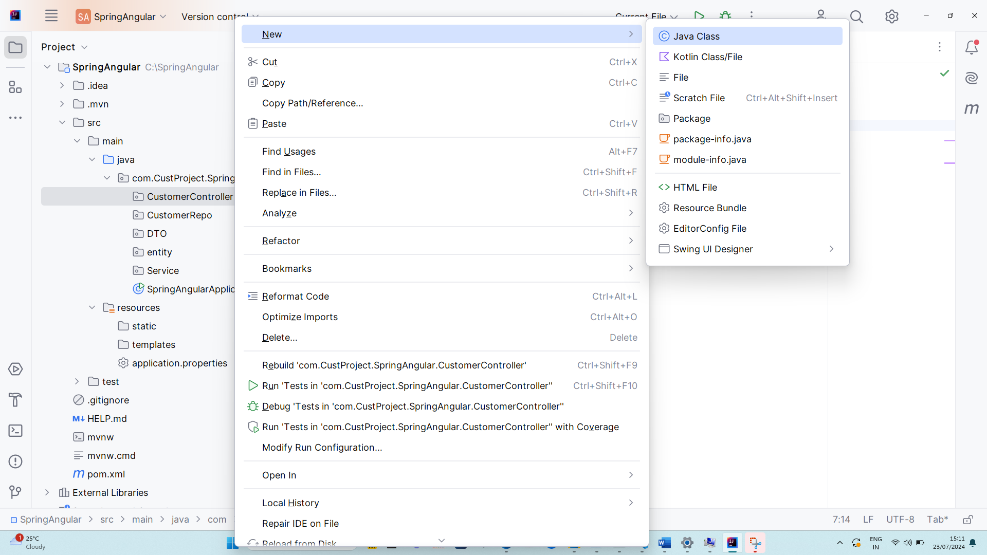

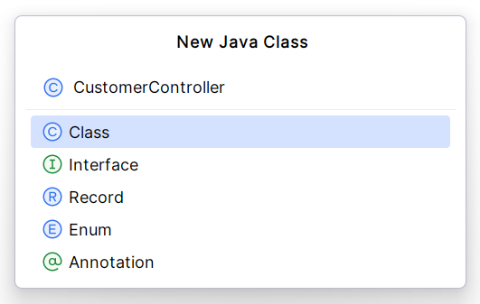

Then add annotations by using “@” symbol a drop down will be displayed

Add the following annotations

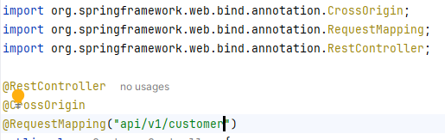

Select from the dropdown and the annotations will be automatically imported.

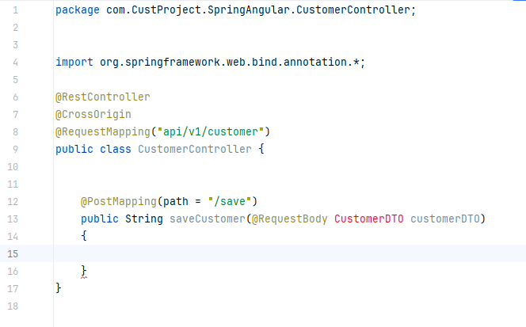

Now create class “Customer” for the **Entity package** in the same way

Import “@Table (name = “Customer”)

Declaration of variables

Then right click and click on “Generate” to generate parameterized constructor

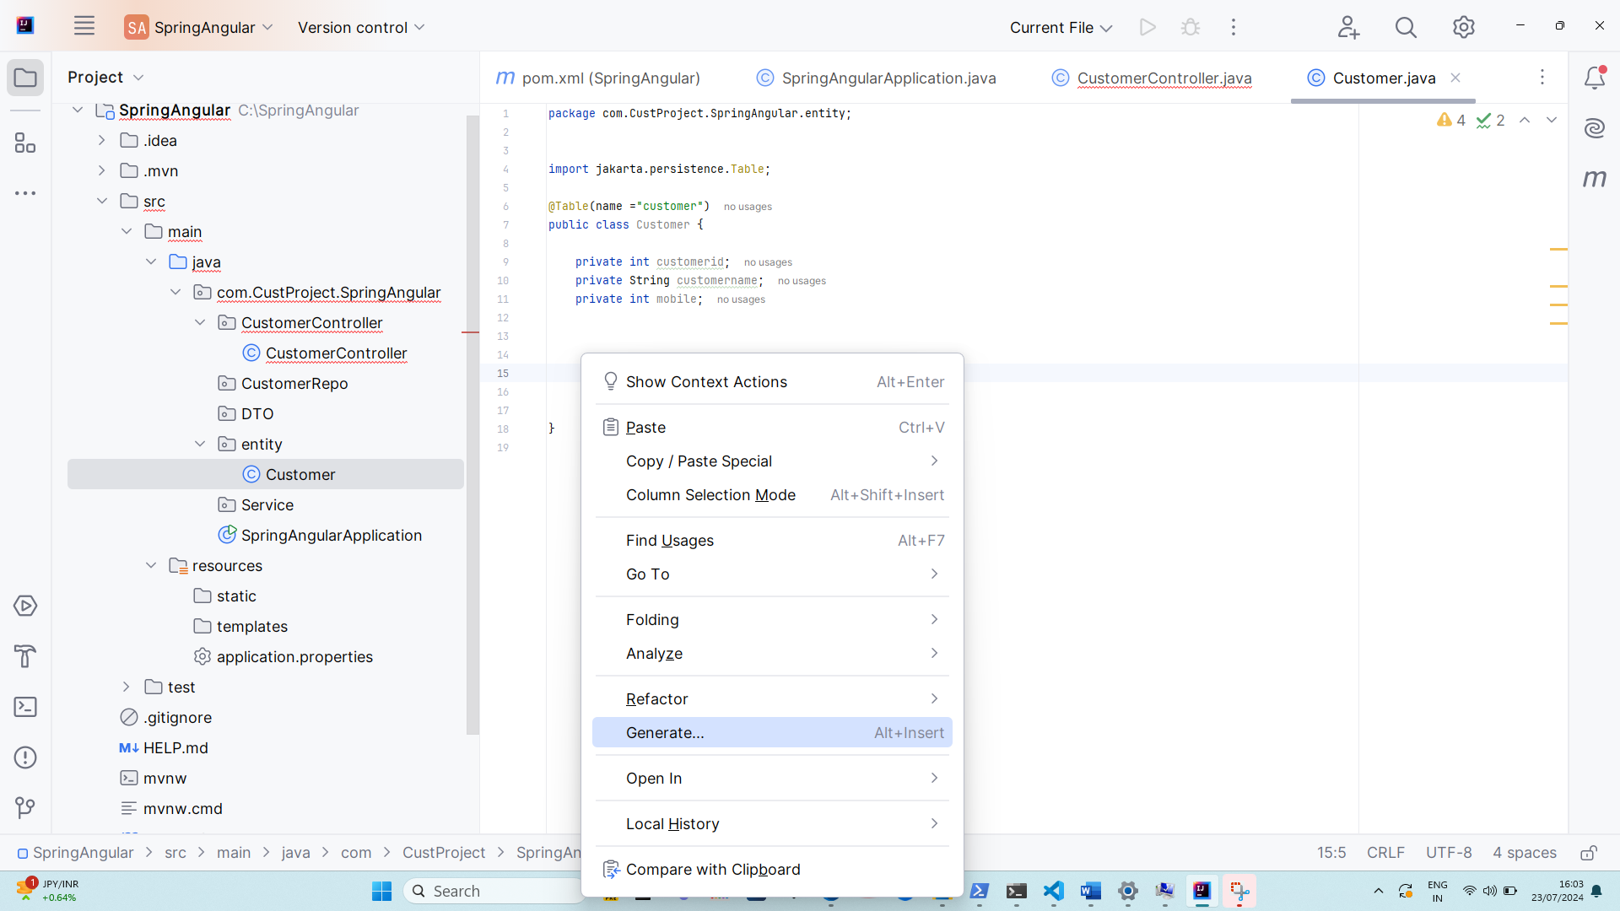

Generate --- Constructor --- select all ---Ok

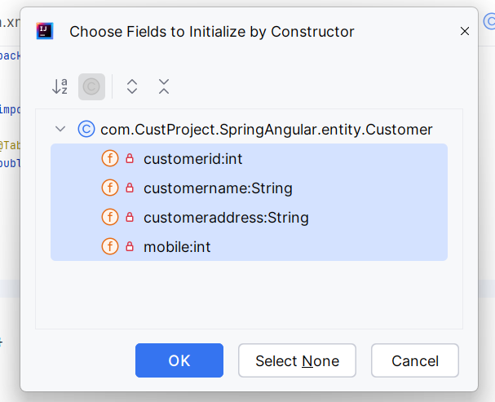

We need an empty Constructor too

Therefore, right click --- Generate --- Constructor ---- Select None

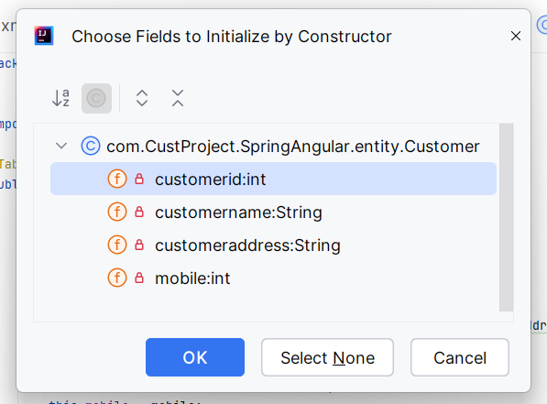4

To generate getter & setter methods:

Right click --- Generate ---Getter and Setter--- select all--- ok

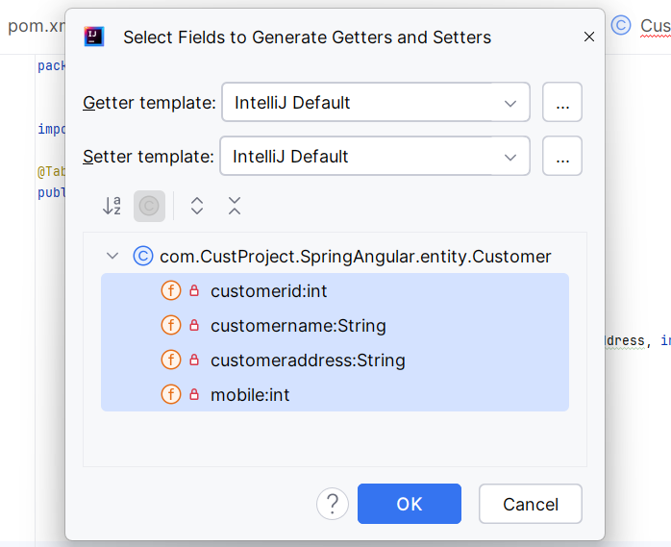

Generate toString() method in the same way

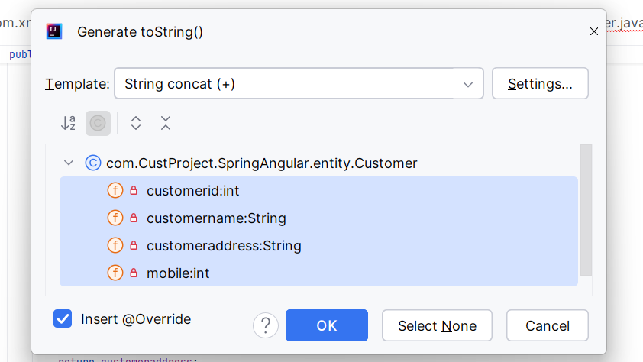

**Customer.java**

package com.CustProject.SpringAngular.entity;  
  
  
import jakarta.persistence.*;  
  
@Table(name ="customer")  
public class Customer {  
 @Id  
 @Column(name = "customer_id", length = 50)  
 @GeneratedValue(strategy = GenerationType.*AUTO*)  
 private int customerid;  
  
 @Column(name = "customer_name", length = 50)  
 private String customername;  
  
 @Column(name = "customer_address", length = 60)  
 private String customeraddress;  
  
 @Column(name = "mobile", length = 12)  
 private int mobile;  
  
 *//Parameterized Constructor* public Customer(int customerid, String customername, String customeraddress, int mobile) {  
 this.customerid = customerid;  
 this.customername = customername;  
 this.customeraddress = customeraddress;  
 this.mobile = mobile;  
 }  
  
 *//Empty Constructor* public Customer() {  
 }  
  
 *//Getter and Setter Methods* public int getCustomerid() {  
 return customerid;  
 }  
  
 public void setCustomerid(int customerid) {  
 this.customerid = customerid;  
 }  
  
 public String getCustomername() {  
 return customername;  
 }  
  
 public void setCustomername(String customername) {  
 this.customername = customername;  
 }  
  
 public String getCustomeraddress() {  
 return customeraddress;  
 }  
  
 public void setCustomeraddress(String customeraddress) {  
 this.customeraddress = customeraddress;  
 }  
  
 public int getMobile() {  
 return mobile;  
 }  
  
 public void setMobile(int mobile) {  
 this.mobile = mobile;  
 }  
  
 *//toString() method* @Override  
 public String toString() {  
 return "Customer{" +  
 "customerid=" + customerid +  
 ", customername='" + customername + '\'' +  
 ", customeraddress='" + customeraddress + '\'' +  
 ", mobile=" + mobile +  
 '}';  
 }  
}

Now, create “CustomerDTO” java class for **DTO package** in the same way mentioned above

**CustomerDTO.java**

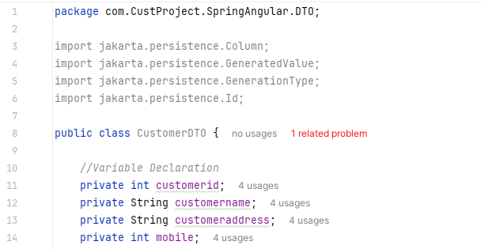

**Same as Customer.java :-**

Variable declaration

Generate Parameterized Constructor

Generate Default Constructor

Generate Getter & Setter Methods

Generate toString() method

Now go back to CustomerConroller.java

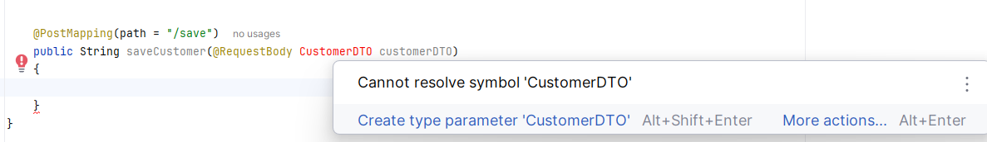

Alt+Shift+Enter and the red CustomerDTO turns black

Create an interface for the **“Service” package**

Right click on Service package --- new --- Java class—select Interface --- type interface name as CustomerService

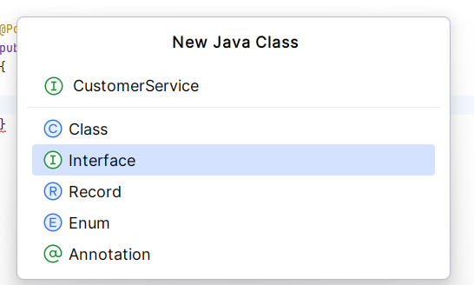

Now create a class for the same package

Right click on Service package --- new --- java class ---type CustomerServiceIMPL

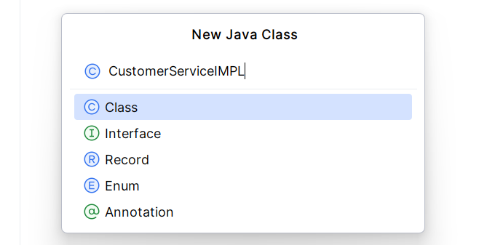

In **CustomerController.java** add @Autowired annotation and hover on addCustomerand click on Create method ‘addCustomer’ in ‘CustomerService’

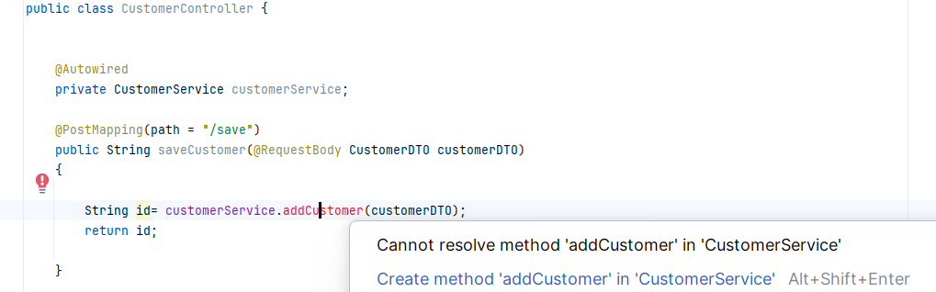

The method will hence be added to the interface file CustomerService.java

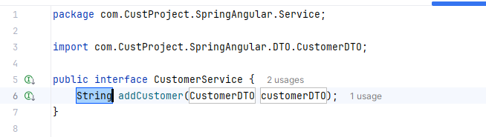

In **CustomerServiceIMPL.java** write:

public class CustomerServiceIMPL implements CustomerService{}

click on the red error bulb that appears --- Implement methods --- select the method --- click ok

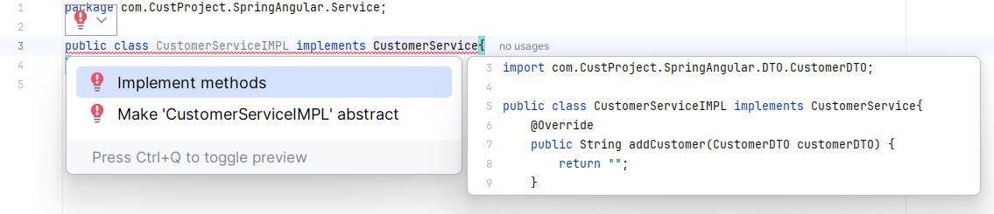

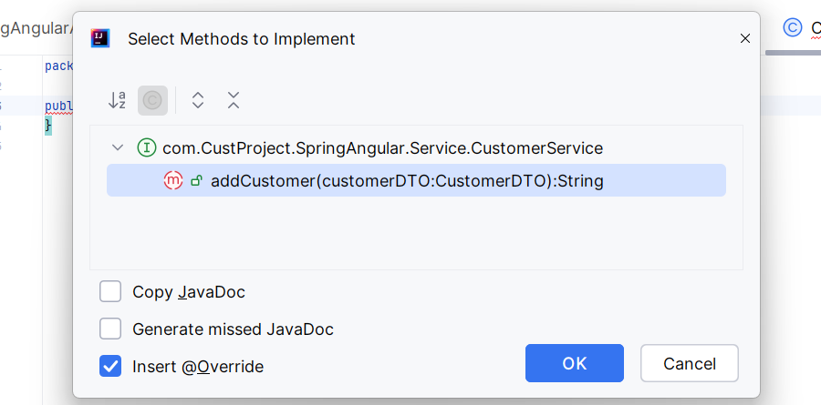

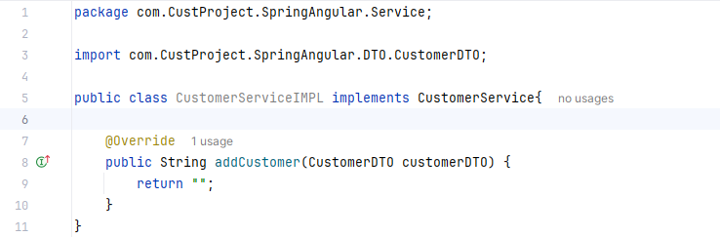

Now we want two DTOs, one for Customer Save purpose and another for Customer Update purposes

Create new classes for the **DTO package:**

Right click on DTO package – new—java class—“CustomerSaveDTO”

Right click on DTO package – new—java class—“CustomerUpdateDTO”

Copy & paste the all the methods from the CustomerDTO class of CustomerDTO.java file to CustomerSaveDTO class of CustomerSaveDTO.java file

Remove all the customerid details, we don’t need customerid as the data is going to be saved directly and doesn’t require any filter such as for update.

Now,

Copy & paste the all the methods from the CustomerDTO class of CustomerDTO.java file to CustomerUpdateeDTO class of CustomerUpdateDTO.java file

Update CustomerDTO and customerDTO to CustomerSaveDTO and customerSaveDTO in CustomerController.java, in CustomerService.java and CustomerServiceIMPL.java

In the **CustomerServiceIMPL.java** file, create an object “customer” for the “Customer” Entity that is present in the **Entity Package**

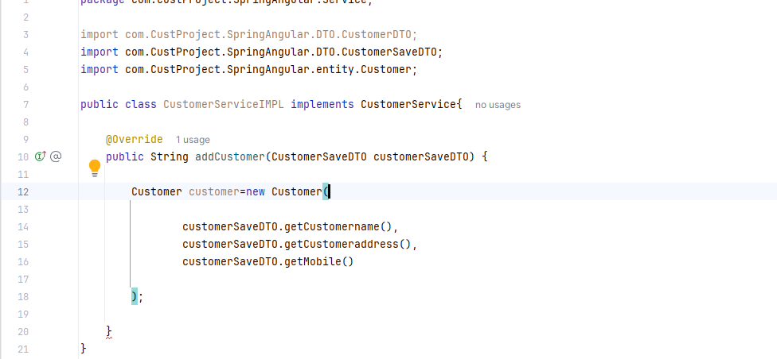

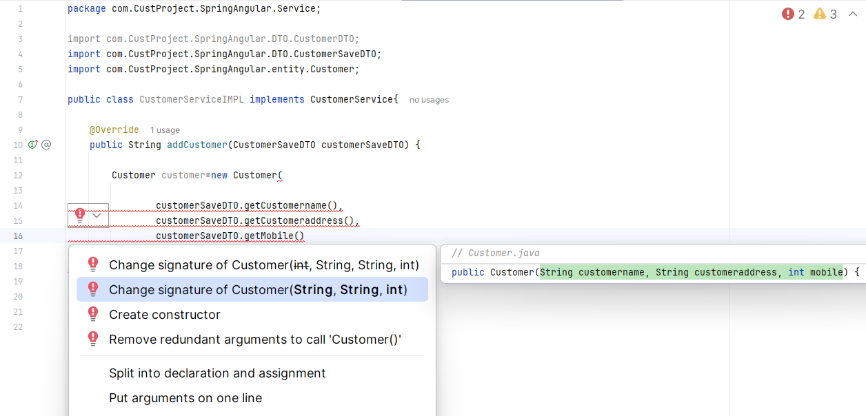

But this has to return some value at line no. 19

For that go to CustomerRepo Package

**Creating a CustomerRepo interface:**

Right click on **CustomerRepo Package** --- new--- java class --- select Interface --- name the interface as “CustomerRepo”

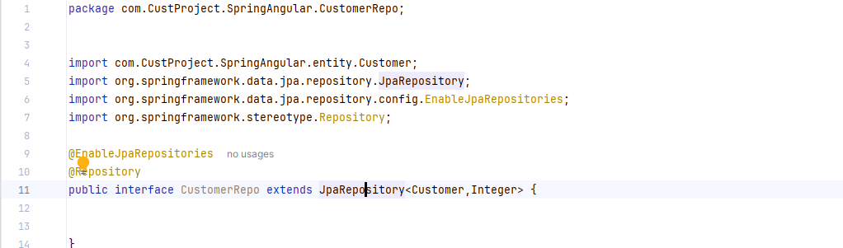

Now to return a value, go back to CustomerServiceIMPL.java and add the following:

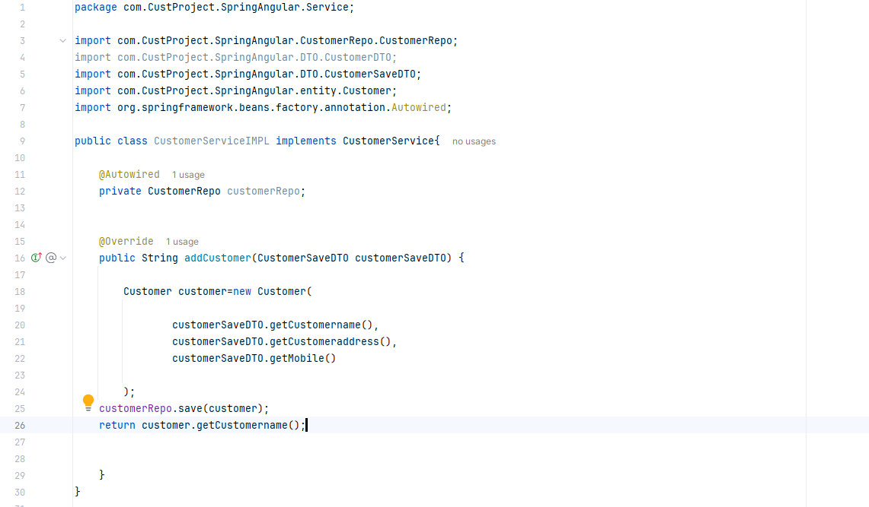

Now go to resources folder --- application properties and write the code for the database connection

**Database Connection using MySQL Workbench 8.0 CE**

[**MySQL :: Download MySQL Installer**](https://dev.mysql.com/downloads/installer/) **(link)**

Install the upper download link

Select custom to install only custom files, here I have done full

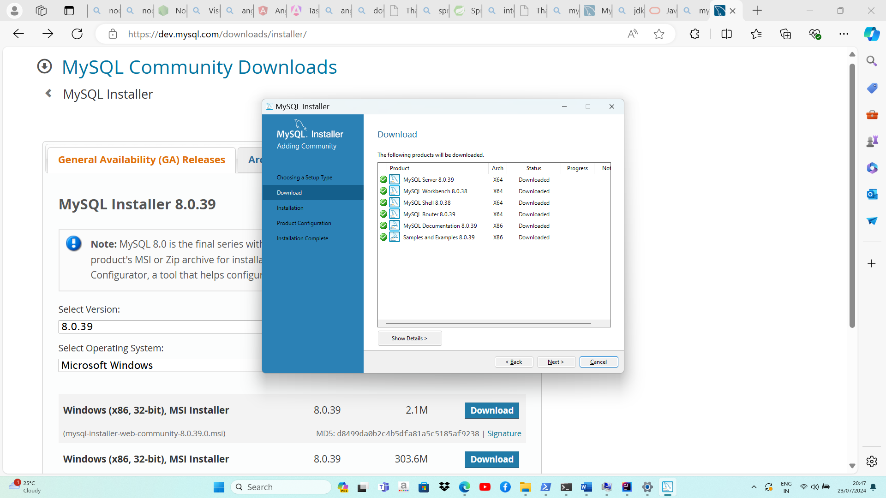

Click on Execute--next

Click next – next

Enter the Password under Accounts and Roles (pass: aish300897)

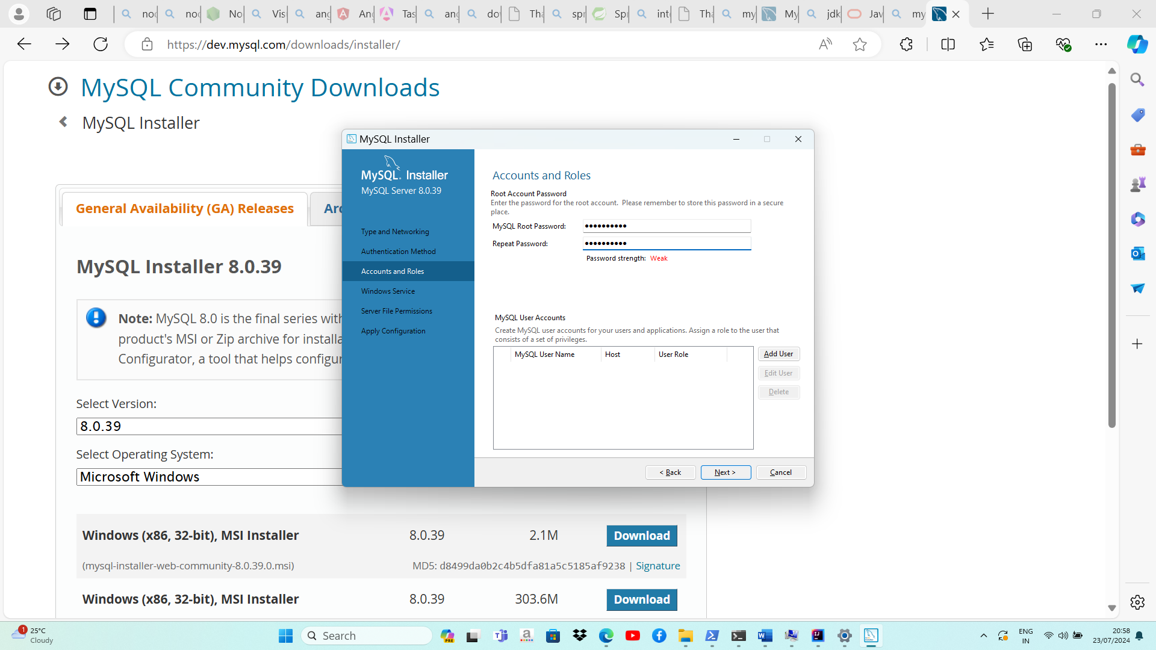

Click next --- next --- execute--- finish

Click on the “+” sign beside the MySQL Connections

Enter connection name (here it is crudnew)

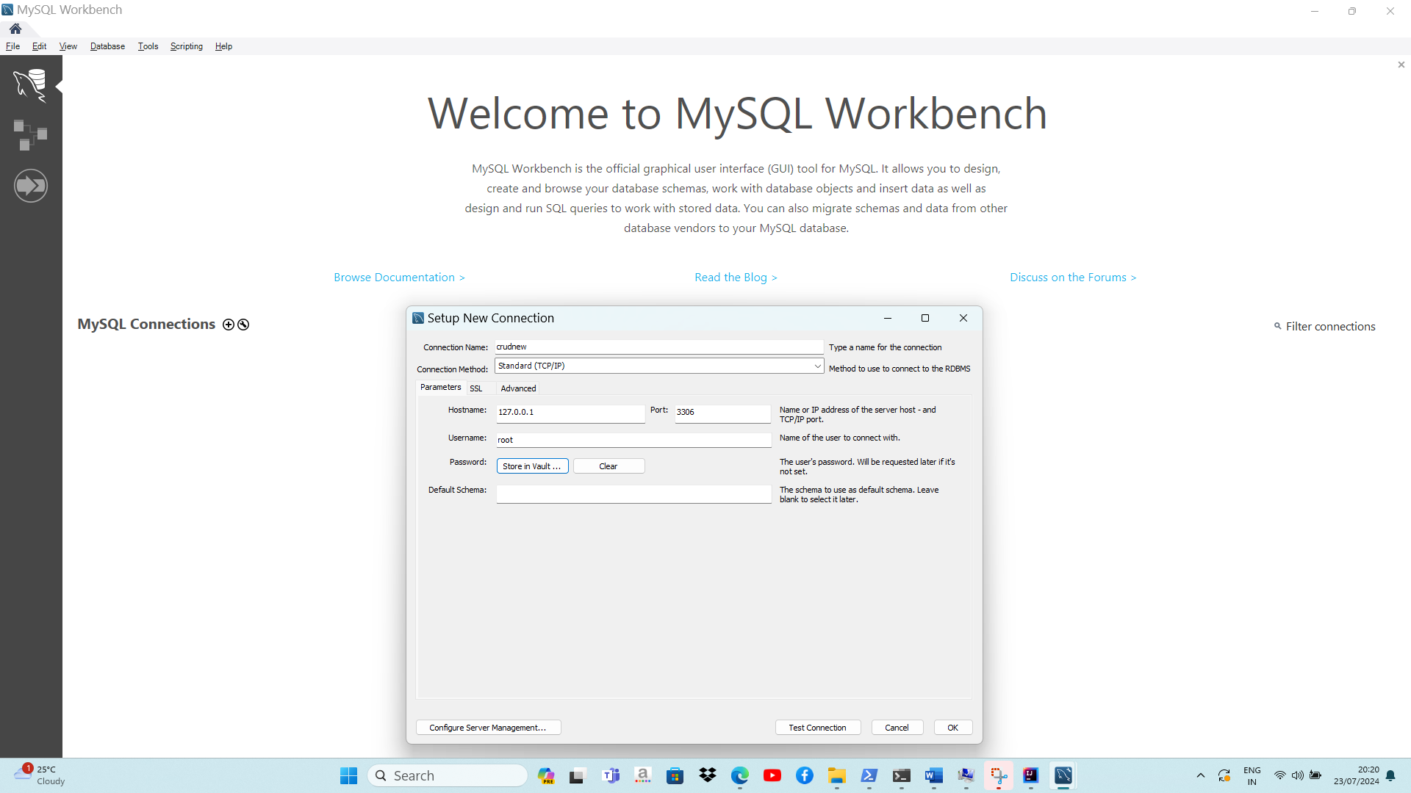

For password, click “Store in vault”

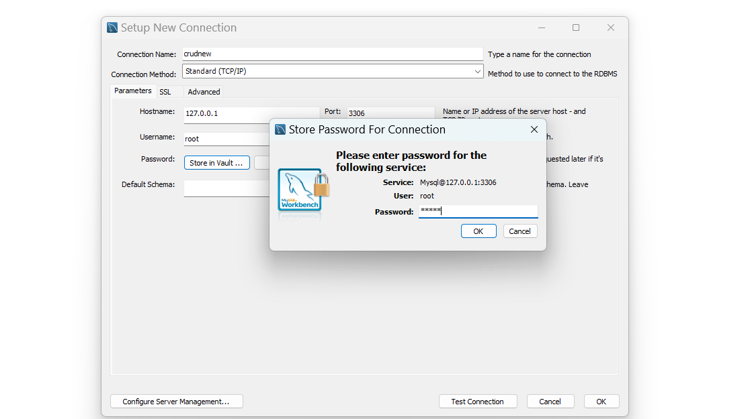

Password : aish300897 --- ok --- Test Connection

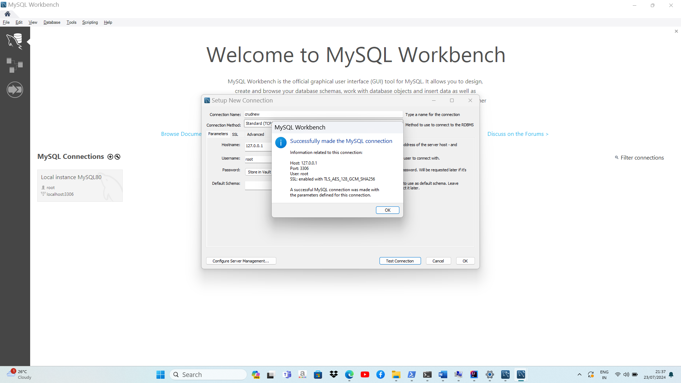

Now,

Write the following lines with username and password according to the credentials you provided while downloading MySQL Workbench Installer in **application.properties** of resources folder.

Where, gmsschool is the database name

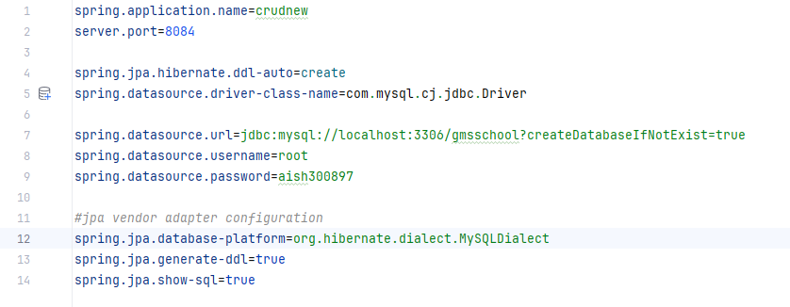

Click on the Green Play Button on the top to run the code

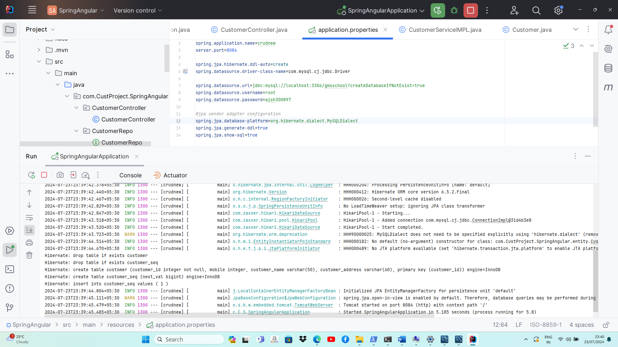

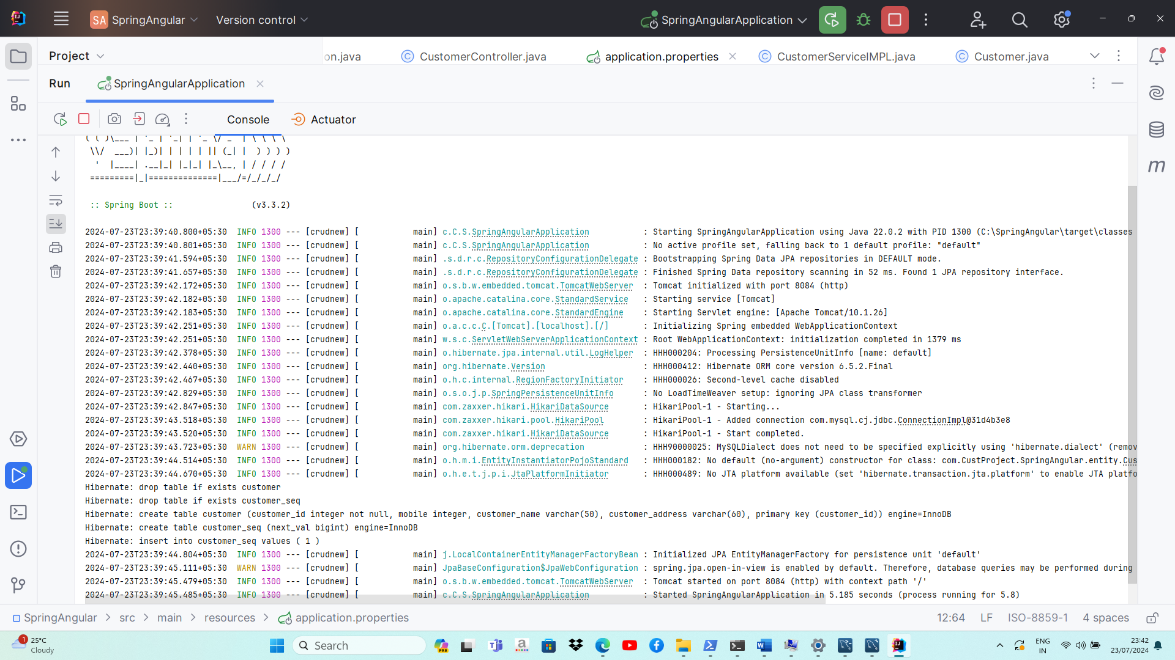

**Download Postman**

[**Download Postman | Get Started for Free**](https://www.postman.com/downloads/) **(link)**

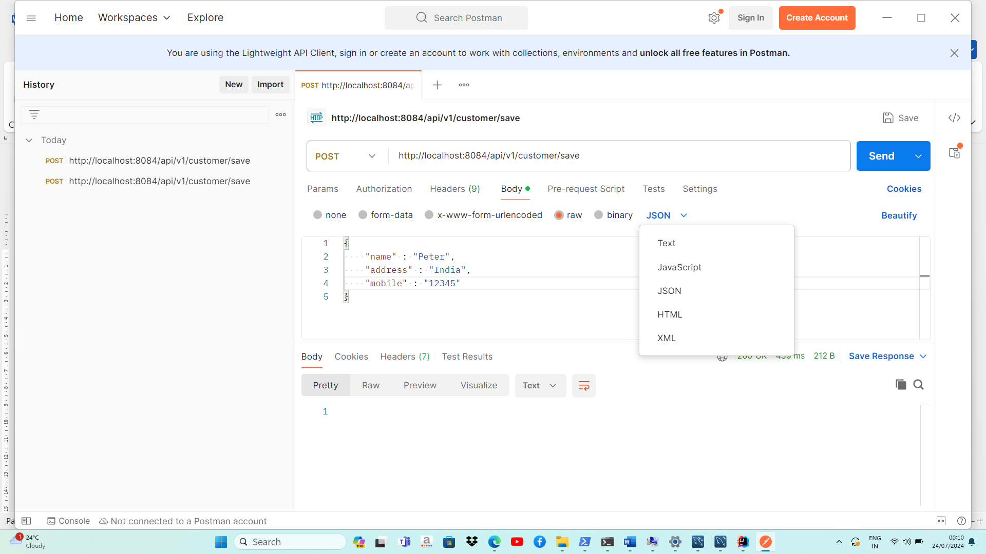



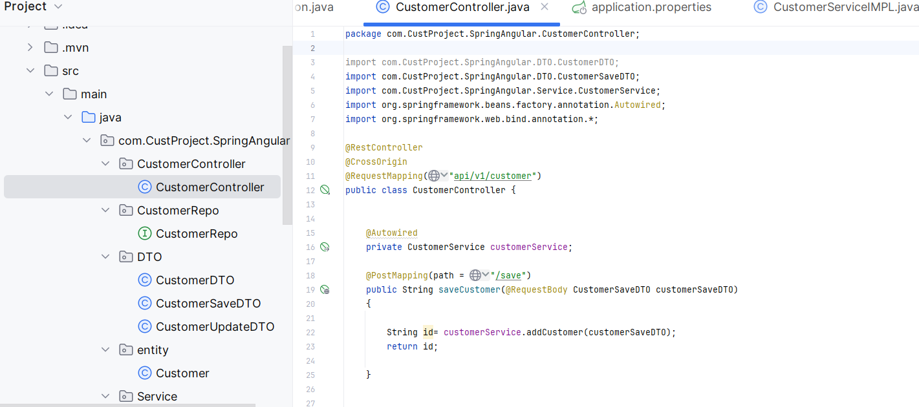



Go back to IntelliJ --- Menu--- View --- Tool Windows ---Databases

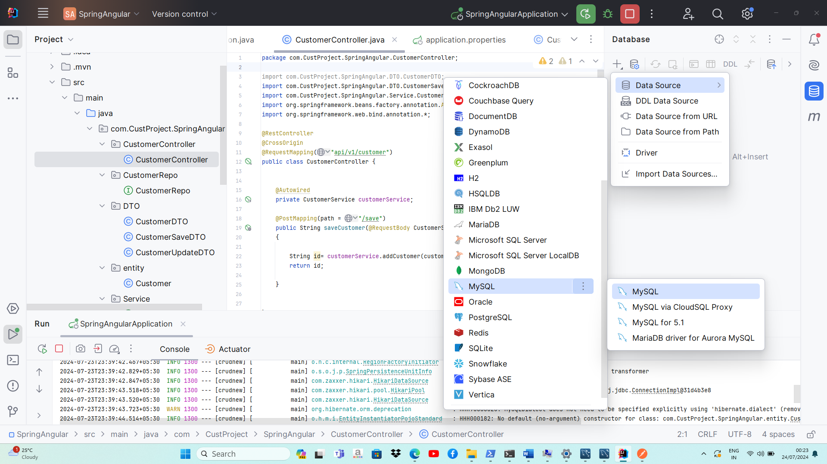



Click on the “+”—Data Source—MySQL --- MySQL for 5.1

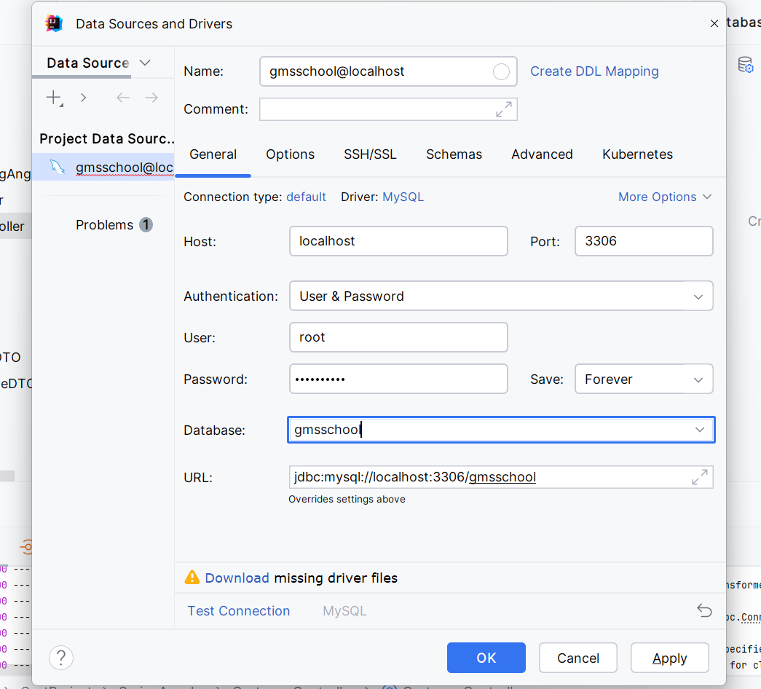

Enter User, Password, Database as in the application.properties

Click Apply --- OK

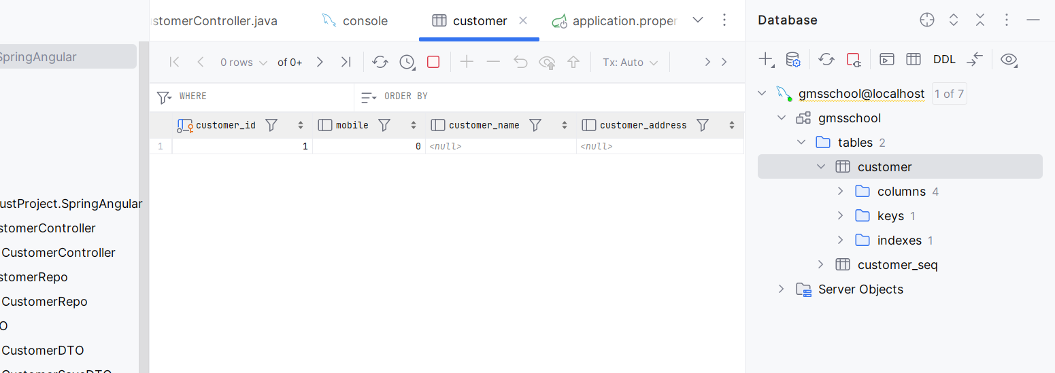

Since the values in the table are null, one more parameterized constructor is added in Entity Package --- Customer.java

Excluding id – right click generate—constructor—select name, address, mobile--- ok

Stop & Rerun by clicking on the play button

Click send on the postman app once again

Check the customer table once again in IntelliJ

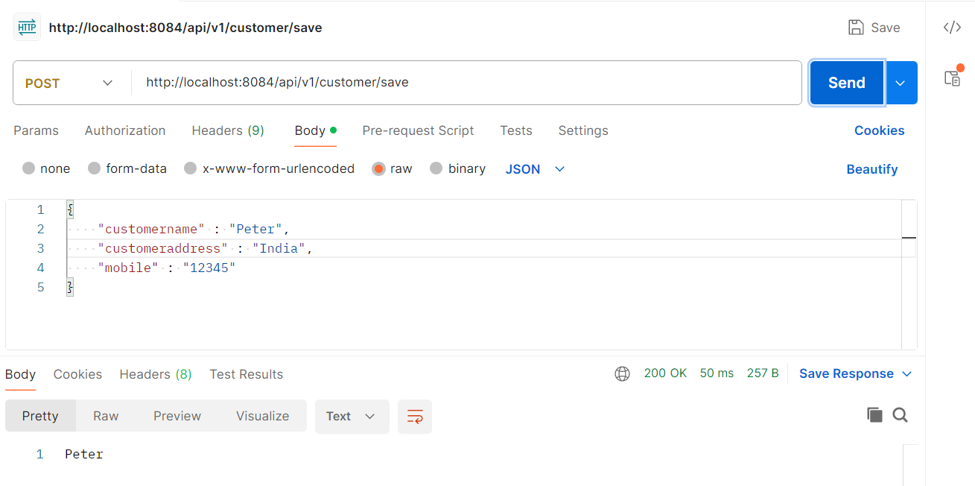

Refresh – IntelliJ Customer table

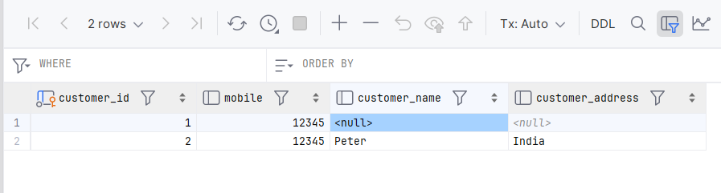

Now, for retrieving the data go to CustomerController.java

Write code for GetMapping similar to PostMapping

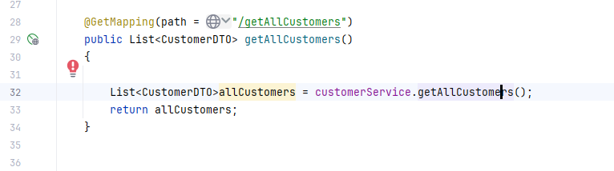

Hover on .getAllCustomers() and create a separate method

An error can be seen in the CustomerServiceIMPL hence, hover on the error and click on the “implement methods”

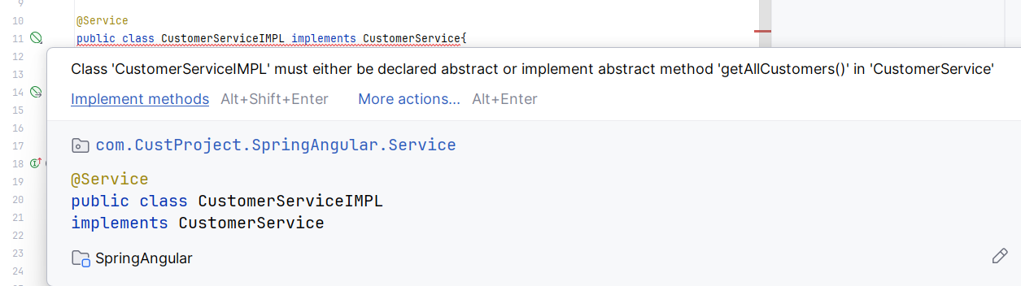

Click ok on the dialog box

**CustomerServiceIMPL.java**

Add following lines of code into the file—save all—stop & rerun

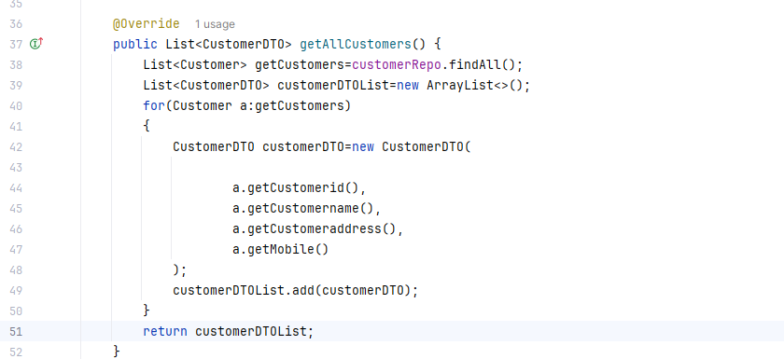

Go to Postman and check for the Get method with “/getAllCustomers”

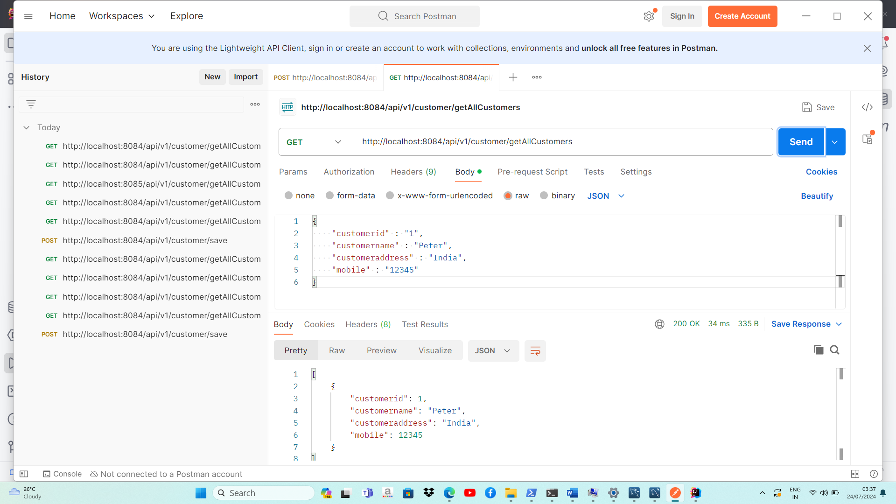

Now to update and delete the Customer records-

**CustomerController.java**

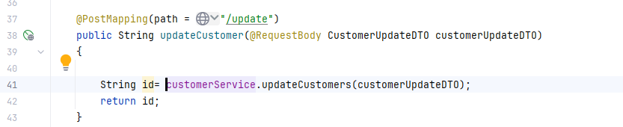

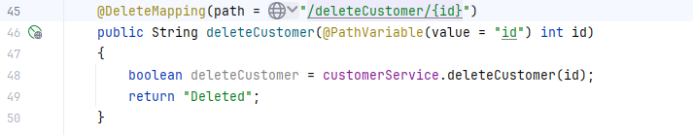

**CustomerServiceIMPL.java**

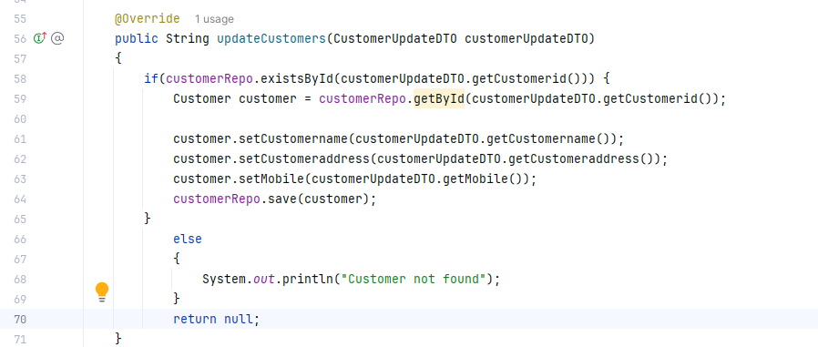

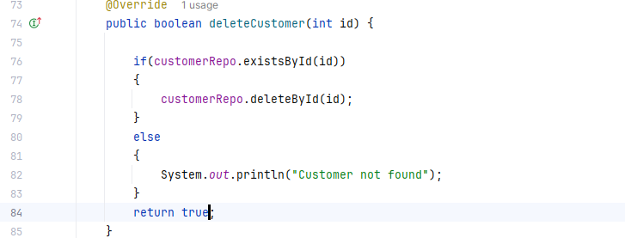

**POST :** <http://localhost:8084/api/v1/customer/save>

**GET :** <http://localhost:8084/api/v1/customer/getAllCustomers>

**PUT :** <http://localhost:8084/api/v1/customer/update>

**DELETE :** http://localhost:8084/api/v1/customer/deleteCustomer/3

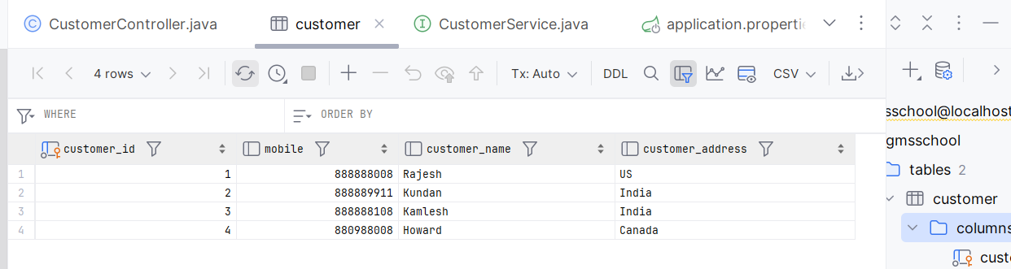

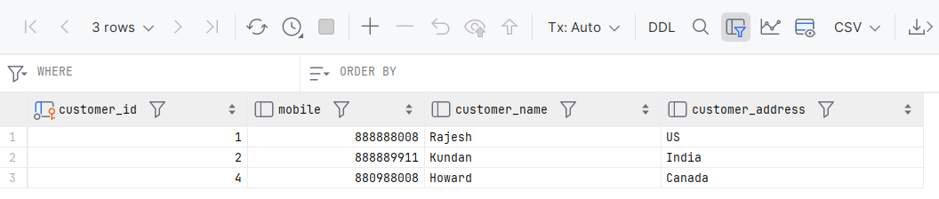

**FRONT END DEVELOPMENT:**

For the front end, first create a new folder, here I have created a folder named “SpringCrud”.

Move your backend project folder “SpringAngular” into this new folder. Go inside the folder and open cmd (C:\SpringCrud 🡪here)

Run the following commands one by one:

**npm install -g @angular/cli** (installs angular cli)

**ng new crud-frontend** (creates a project with the given name)

If your VS Code version is the latest one, it may not have app.module.ts file

Then, create a new project with the following command:

**ng new crud-frontend - -no-standalone (u can now see app.module.ts in VS Code)**

//Then, select SCSS and Y

**cd crud-frontend** (to navigate to the project)

**ng serve** (to run the project)

//Application bundle generation complete

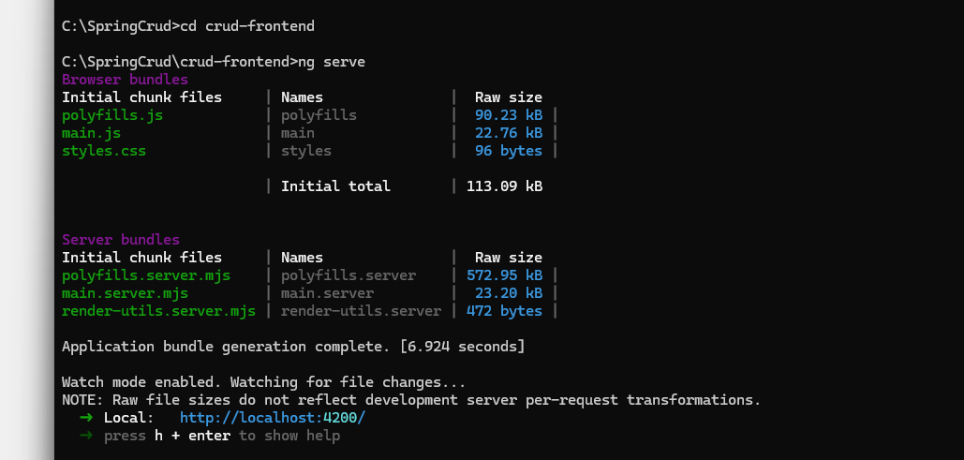

Copy the url given i.e., <http://localhost:4200/> and paste it on the web browser

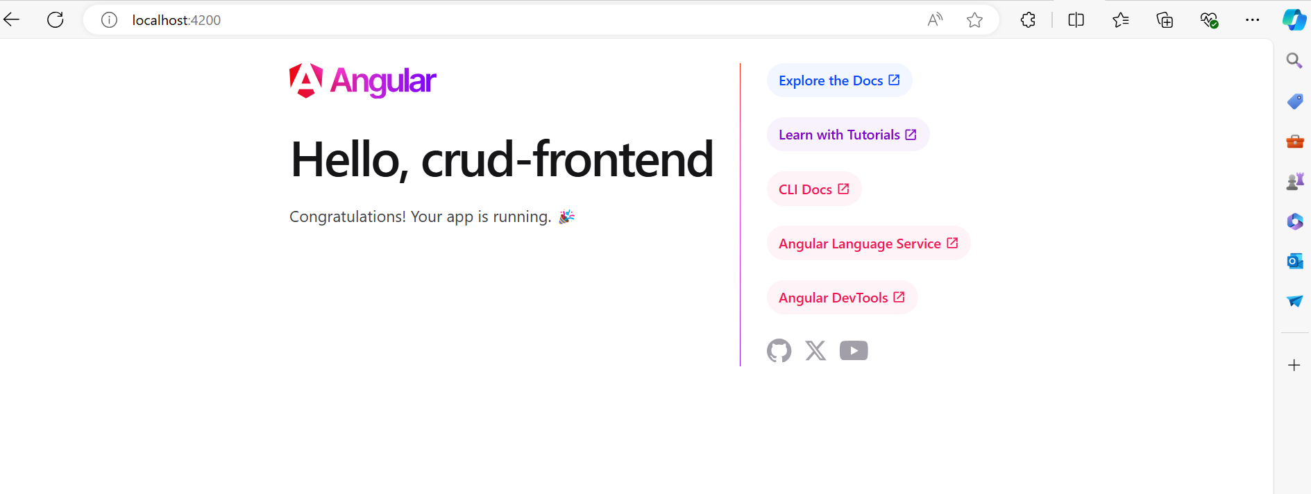

Now go inside your created project folder and open cmd from that location (C:\SpringCrud\crud-frontend 🡪here)

Run “**code .”** command and it will open your newly created project on VS code application instantly without the need to open your it separately.

Now on the same command prompt run the command:

**ng g c customer** to generate component named customer

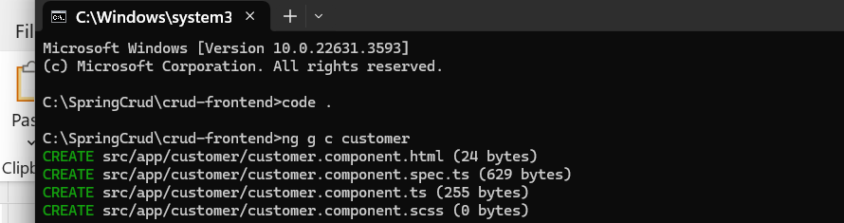

The component is hence successfully created in the VS Code 🡪src🡪app🡪customer

Now install bootstrap by using the **npm i bootstrap** command in the same cmd

**Pushing code from local to GITHUB**

Download Git [Git - Downloading Package (git-scm.com)](https://git-scm.com/download/win)

Now open the “**Git Bash Here”** by right clicking in the SpringCrud folder that contains your project.

Type the following commands

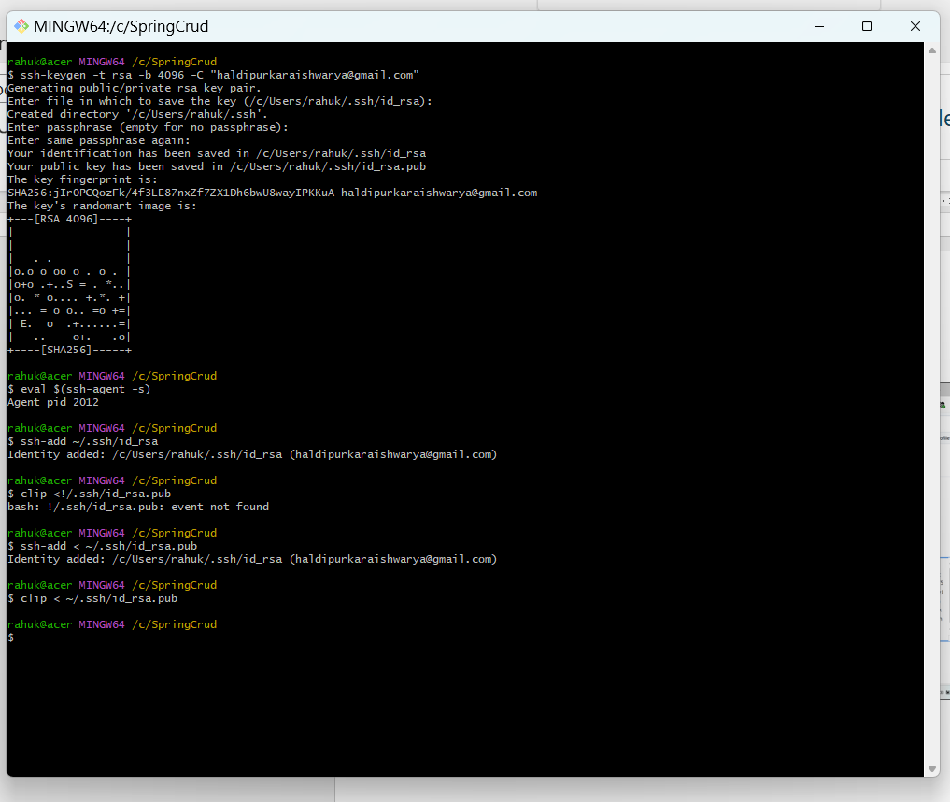

after the clip command the ssh key will be automatically copied which u have to paste on your github account

your profile 🡪 settings 🡪 SSH and GPG keys 🡪 give title 🡪 Cntrl+V

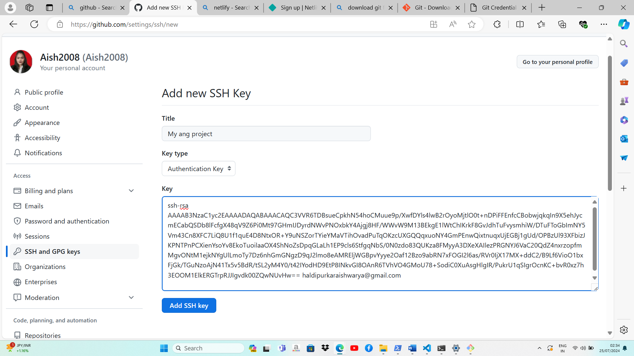

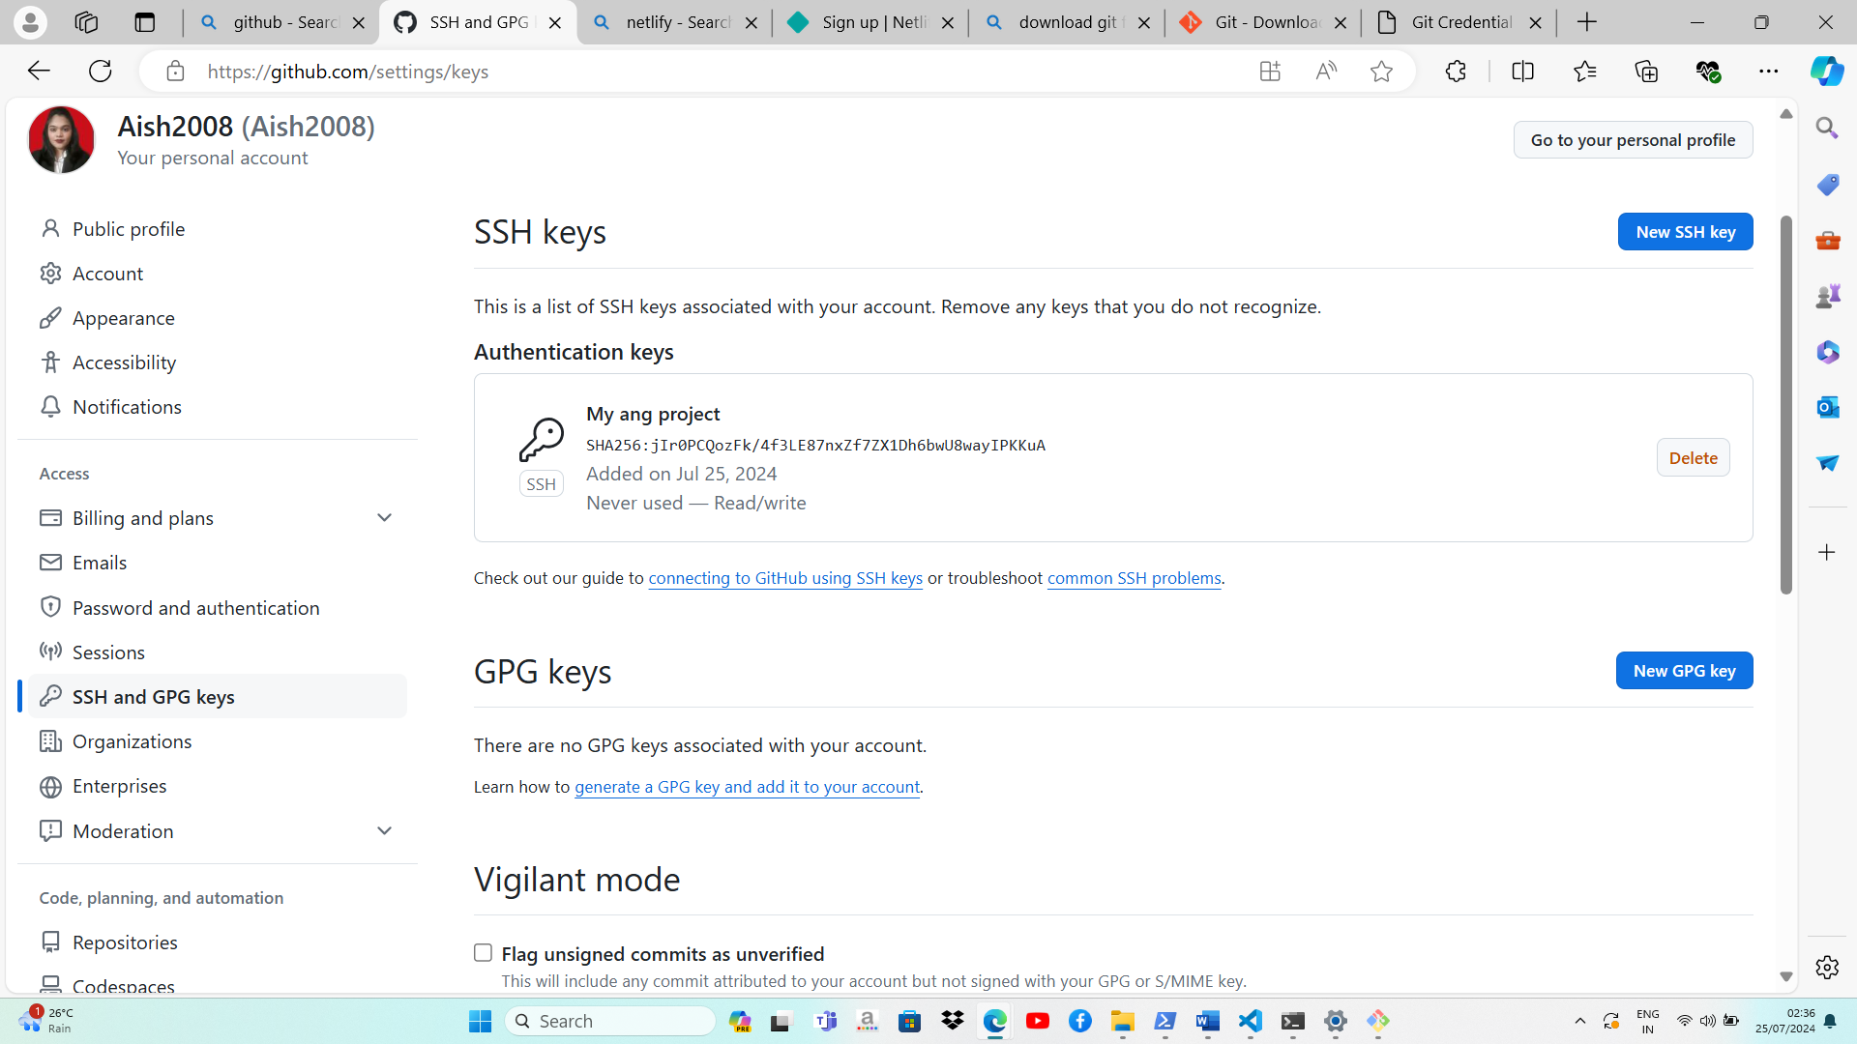

Create new repository, here **Angular_CustomerRecords**

Now, open “**Git bash Here”**  again in your project folder that is C:\SpringCrud by right clicking

